Louisiana Tech University

ELEN 479: Automatic Control Systems Lab
Fall 2023
Lab 1

FAMILIARIZATION WITH SISO OPEN LOOP, CLOSE LOOP CONTROL SYSTEM AND MODELLING IN MATLAB/SIMULINK TOOL BOX.

OBJECTIVE:
To obtain
- Familiarity with the MATLAB and Simulink environments.
- Understanding on how to develop MATLAB scripts to obtain step response of a unity feedback system having forward path transfer function.
- Preliminary insight into creating block diagram models of dynamical systems and to simulate these models in MATLAB and Simulink.

Theory:
MATLAB (MATrix LABoratory) is a software package that is widely used in control systems design. Simulink is a graphical front end to MATLAB that allows you to easily create models of dynamical systems in form of block diagrams. In this lab, you will learn how to implement a simple representation of the model of a simple RLC circuit and simulate its behavior.
A transfer function is known as the network function is a mathematical representation, in terms of spatial or temporal frequency, of the relation between the input and output of a (linear time invariant) system. The transfer function is the ratio of the output Laplace Transform to the input Laplace Transform assuming zero initial conditions. Many important characteristics of dynamic or control systems can be determined from the transfer function. The transfer function is commonly used in the analysis of single-input single-output electronic system, for instance. It is mainly used in signal processing, communication theory, and control theory. The term is often used exclusively to refer to linear time-invariant systems (LTI). In its simplest form for continuous time input signal x(t) and output y(t), the transfer function is the linear mapping of the Laplace transform of the input, X(s), to the output Y(s). Zeros are the value(s) for z where the numerator of the transfer function equals zero. The complex frequencies that make the overall gain of the filter transfer function zero. Poles are the value(s) for z where the denominator of the transfer function equals zero. The complex frequencies that make the overall gain of the filter transfer function infinite. The general procedure to find the transfer function of a linear differential equation from input to output is to take the Laplace Transforms of both sides assuming zero conditions, and to solve for the ratio of the output Laplace over the input Laplace. The transfer function provides a basis for determining important system response characteristics without solving the complete differential equation. As defined, the transfer function is a rational function in the complex variable ‘s’ that is It is often convenient to factor the polynomials in the numerator and the denominator, and to write the transfer function in terms of those factors:
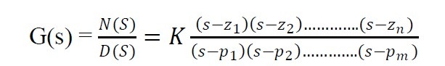
where, the numerator and denominator polynomials, N(s) and D(s). The values of s for which N(S) = 0, are known as zeros of the system. i.e; at s = 𝑧1, 𝑧2,….., 𝑧𝑛. The values of s for which D(S) = 0, are known as poles of the system. i.e; at s = 𝑝1, 𝑝2,….., 𝑝𝑛.
Although there are various methods to derive the transfer functions, for this lab you will be using the Laplace Method and MATLAB.
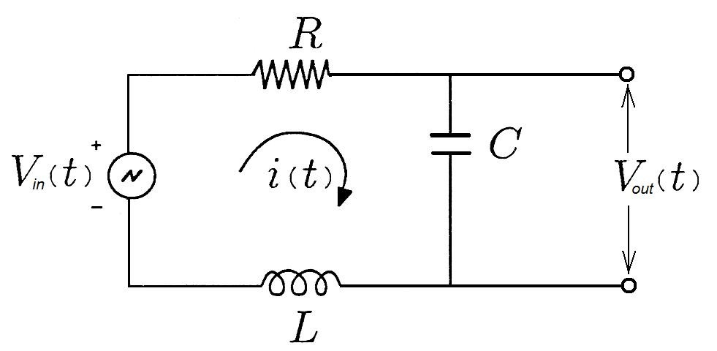
Adding the voltages in the RLC series circuit, using Kirchhoff’s voltage law, and applying the basic equation for voltage drop in electrical components:
Eq 1
In this circuit the output voltage is measured across the capacitor. We assume that the measuring of the output voltage is done using a circuit that represents very high impedance, so that the measuring of the output voltage is done using a circuit that presents very high impedance, so that there is no flow of current disturbing the series circuit, then we have:
Eq 2

We could as well measure the output voltage measured across the resistor terminals, if that were to suit our purposes, but this equation will serve for now. Since , Eq.1 becomes:
Eq 3
If we apply the Laplace transform to Eq 3, each differential operator is replaced by a multiplication by the variable s of the Laplace Transform:
Eq 4
Then we apply the Laplace Transform to Eq 2:
Eq 5
Finally, we divide Eq 5 by Eq 4, and so we get the transfer function of the RLC circuit:
Eq 6
The goal of any electrical or electronic control system is to measure, monitor, and control a process and one way in which we can accurately control the process is by monitoring its output and “feeding” some of it back to compare the actual output with the desired output to reduce the error and if disturbed, bring the output of the system back to the original or desired response. The quantity of the output being measured is called the “feedback signal”, and the type of control system which uses feedback signals to both control and adjust itself is called a Close-loop System.
A Closed-loop Control System, also known as a feedback control system is a control system which uses the concept of an open loop system as its forward path but has one or more feedback loops (hence its name) or paths between its output and its input. The reference to “feedback”, simply means that some portion of the output is returned “back” to the input to form part of the systems excitation. Closed-loop systems are designed to automatically achieve and maintain the desired output condition by comparing it with the actual condition. It does this by generating an error signal which is the difference between the output and the reference input. In other words, a “closed-loop system” is a fully automatic control system in which its control action being dependent on the output in some way
Closed-Loop Control System

If in a physical system there is no automatic correction of the variation in its output, it is called an open loop control system. That is, in this type of system, sensing of the actual output and comparing of this output (through feedback) with the desired input does not take place. The system on its own is not able to give the desired output and it cannot consider the disturbances. In these systems, the changes in output can be corrected only by changing the input manually. These systems are simple in construction, stable and cost cheap. But these systems are inaccurate and unreliable. Moreover, these systems do not take account of external disturbances that affect the output and they do not initiate corrective actions automatically.
Open-Loop Control Systems
Closed-loop systems have many advantages over open-loop systems. The primary advantage of a closed- loop feedback control system is its ability to reduce a system’s sensitivity to external disturbances, for example opening of the dryer door, giving the system a more robust control as any changes in the feedback signal will result in compensation by the controller.
Then we can define the main characteristics of Closed-loop Control as being:
- To reduce errors by automatically adjusting the systems input.
- To improve stability of an unstable system.
- To increase or reduce the systems sensitivity.
- To enhance robustness against external disturbances to the process.
- To produce a reliable and repeatable performance.
Whilst a good closed-loop system can have many advantages over an open-loop control system, its main disadvantage is that to provide the required amount of control, a closed-loop system must be more complex by having one or more feedback paths. Also, if the gain of the controller is too sensitive to change in its input commands or signals it can become unstable and start to oscillate as the controller tries to over-correct itself, and eventually something would break. So, we need to “tell” the system how we want it to behave within some pre-defined limits.
For a closed-loop feedback system to regulate any control signal, it must first determine the error between the actual output and the desired output. This is achieved using a summing point, also referred to as a comparison element, between the feedback loop and the systems input. These summing points compare a system set point to the actual value and produce a positive or negative error signal which the controller responds too. Error = Set point – Actual.
The symbol used to represent a summing point in closed-loop systems block-diagram is that of a circle with two crossed lines as shown. The summing point can either add signals together in which a Plus ( + ) symbol is used showing the device to be a “summer” (used for positive feedback), or it can subtract signals from each other in which case a Minus ( − ) symbol is used showing that the device is a “comparator” (used for negative feedback) as shown.
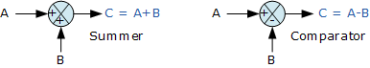
Note that summing points can have more than one signal as inputs either adding or subtracting but only one output which is the algebraic sum of the inputs. Also, the arrows indicate the direction of the signals. Summing points can be cascaded together to allow for more input variables to be summed at a given point.
The Transfer Function of any electrical or electronic control system is the mathematical relationship between the systems input and its output, and hence describes the behavior of the system. Note also that the ratio of the output of a device to its input represents its gain. Then we can correctly say that the output is always the transfer function of the system times the input. Consider the closed-loop system below.
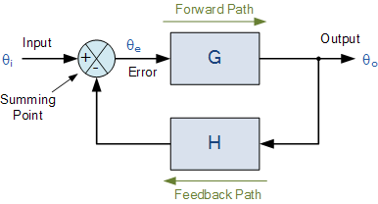

Where: block G represents the open-loop gains of the controller or system and is the forward path, and block H represents the gain of the sensor, transducer or measurement system in the feedback path. To find the transfer function of the closed-loop system above, we must first calculate the output signal θ_{o} in terms of the input signal θ_{i}. To do so, we can easily write the equations of the given block-diagram as follows.

The output from the system is equal to: Output = G x Error
Note that the error signal, θ_{e} is also the input to the feed-forward block: G
The output from the summing point is equal to: Error = Input - H x Output
If H = 1 (unity feedback) then:
The output from the summing point will be: Error (θ_{e}) = Input - Output Eliminating the error term, then:
The output is equal to: Output = G x (Input - H x Output) Therefore: G x Input = Output + G x H x Output
Rearranging the above gives us the closed-loop transfer function of:
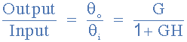
The above equation for the transfer function of a closed-loop system shows a Plus ( + ) sign in the denominator representing negative feedback. With a positive feedback system, the denominator will have a Minus ( − ) sign and the equation becomes: 1 - GH. We can see that when H = 1 (unity feedback) and G is very large, the transfer function approaches unity as:
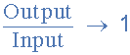
Also, as the systems steady state gain G decreases, the expression of: G/(1 + G) decreases much more slowly. In other words, the system is insensitive to variations in the systems gain represented by G, and which is one of the main advantages of a closed-loop system.

Lab Instructions
Relevant function descriptions pulled from MATLAB documentation.
sys = tf(numerator,denominator) creates a continuous-time transfer function model, setting the Numerator and Denominator properties. For instance, consider a continuous-time SISO dynamic system represented by the transfer function sys(s) = N(s)/D(s), the input arguments numerator and denominator are the coefficients of N(s) and D(s), respectively.
sys = feedback(sys1,sys2) returns a model object sys for the negative feedback interconnection of model objects sys1, sys2.
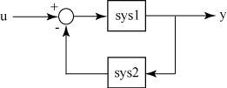
From the figure, the closed-loop model sys has u as input vector and y as output vector. Both models, sys1 and sys2, must either be continuous or discrete with identical sample times.
step(obj,___) calls the System object™ and runs the algorithm. Depending on your System object, step can return output arguments.

Task 1:
- Write a MATLAB code that can create a transfer function for the RLC series circuit in s-domain. (Assuming R=1 L=1 C=1)
- Implement in your code to obtain a step response of a unity feedback system having forward path for the RLC transfer function
- Save a graph of the step response over 50 seconds.

Task 2:
Develop a Simulink Model of the RLC circuit using Simulink and then obtain a step response of a unity feedback system having forward path for the RLC transfer function. Save a graph of that response
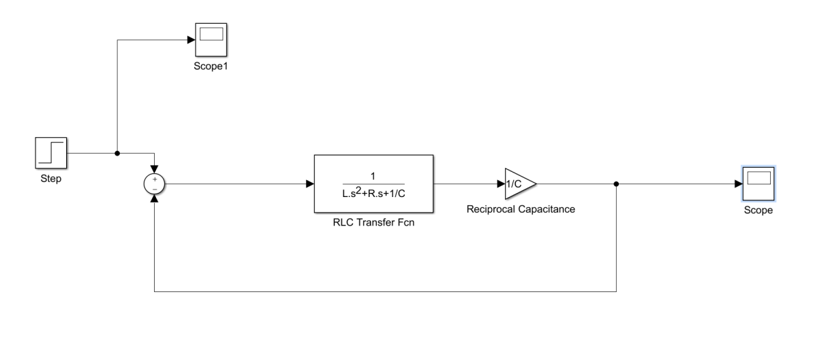

Post Lab:
- Discuss/Analyze the following:
  - What is the significance of transfer function?
  - Compare results from Task 1 and Task 2. Are they similar? Comment on it.
- Create a Simulink Model of an open loop RLC transfer function and plot the output graph. What’s different from the close loop system? Comment on it.

